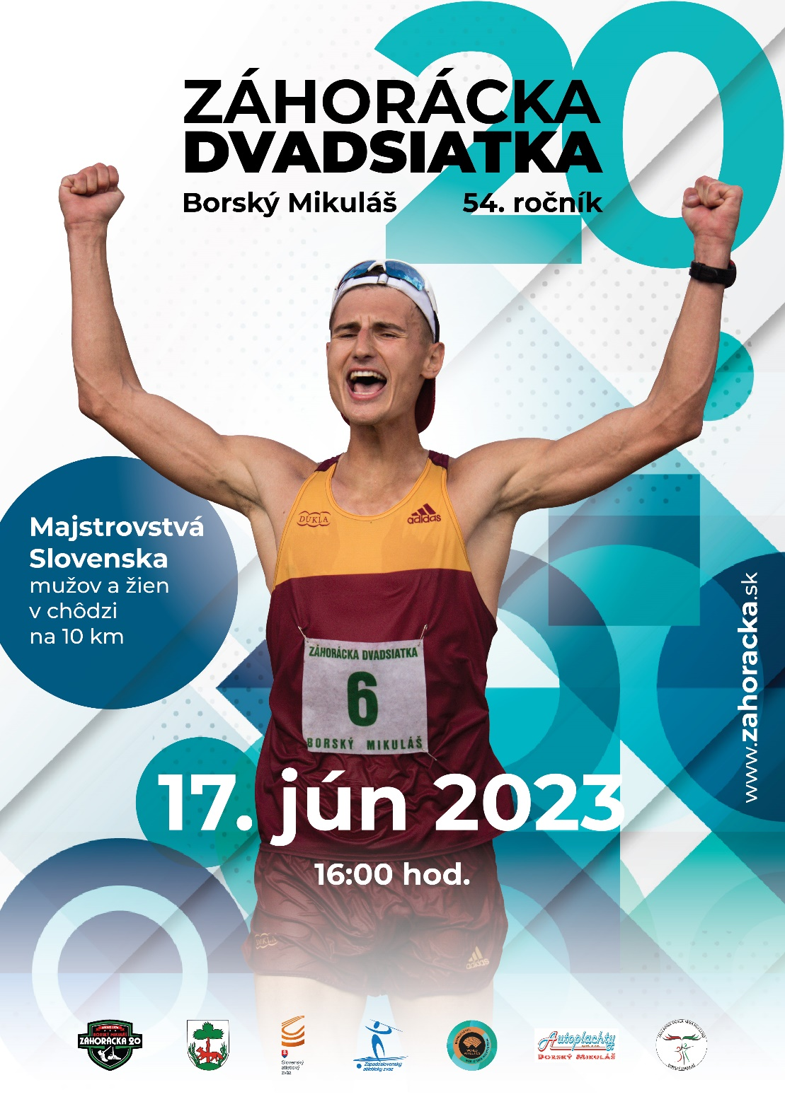

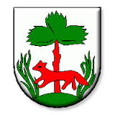
THE DIRECTION 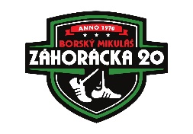

54rd ZÁHORÁCKA DVADSIATKA
INTERNATIONAL RACE WALKING MEETING

ZÁHORÁCKA DVADSIATKA

World Race Walking Tour – Bronze Level
Slovak National Championships 10km Men and Women
Slovak National Championships 5km Masters Men and Women
Race Walking Regional Championschips

Organiser ZÁHORÁCKA DVADSIATKA o.z. and Village Borský Mikuláš by authority of Slovak Athletics Federation

LOC
Chairman of LOC: Bc. Róbert MACEK
Competition Director: Ing. Roman GAZÁREK email: romangazarek68@gmail.com
Meeting Manager: Mgr. Dana GAŠPÁRKOVÁ mob.: +421911523424 email: gasparkovadana1@gmail.com
Technical Manager: Ing. Roman GAZÁREK
Head Referee: Ing. Jozef MALÍK
Technical delagate: Martin ŠKARBA
RW Chief Judge: Štefan MALÍK
RW Judge: Zuzana COSTIN, Orsolya GRUBER, Alexandru STEFAN, Silvia HANUSOVÁ,
Juraj MALÍK

TIMETABLE
16:00 Opening ceremony
16:15 Start of these races: 1 km boys U10
1 km girls U10
16:25 Start of these races: 1 km boys U12
1 km girls U12
16:30 Declaration of the results 1km
16:35 Start of these races: 2 km boys U14
2 km girls U14
16:55 Start of these races: 3 km boys U16
3km girls U16
17:15 Declaration of the results 2km, 3km
17:20 Start of these races: 5 km boys U18
5 km girls U18
5km the men´s masters (17.6.1988 and older)
5km the women´s masters (17.6.1988 and older)
18:00 Start these races: 10 km the mens (2002 and older)
10km the womens (2002 and older)
10km boys U20
10km girls U20
19:00 Declaration of the results 5km, 10km
TECHNICAL INFORMATION
Entries
By email to zahoracka20@gmail.com till 15st June 2023 to 12:00pm. The application must contain: Name,
Surname, Gender, Date of birth, Discipline, Club, Country and personal record.

Check-in and Competition Office
Competition office will be opened on Saturday 17th June 2022 from 1:30pm until the end of the competition in the building of the Elementary School Borský Mikuláš.
Each athlete has to be checked in on Saturday 17th June 2023 by 3:30pm.

Entry fee.
Each registered competitor will pay at the presentation. Entry fee for 10 km – 10,00 euros, 5 km – 5,00 euros,
3 km – 3,00 euros, 2 km – 2,00 euros, 1 km – 1,00 euro.

Changing rooms and showers
Changing rooms, showers and toilets will be available in the elementary school. The organiser is not responsible for any loss or damage to items left in those premises

Athletes’ Participation
All athletes participate on their own risk. They are liable for their health. Parents, coaches or team leaders are responsible for the health of the under aged athletes.
Start of the athlete using special health devices has to be communicated to the Competition director and the Referee before 3.30 pm.
Athletes can compete only over the distance outlined by the “Competition Range by SAF” of their age group

Warm Up
Warm up is allowed only outside of the competition area.

Call Room
All athletes have to report to call room according to timetable below.

Categóry | First Call | Last Call | Leaving to Start
Boys and Girls U10 | 3:50pm | 4:10pm | 4:13pm
Boys and Girls U12 | 4:00pm | 4:20pm | 4:23pm
Boys and Girls U14 | 4:10pm | 4:30pm | 4:33pm
Boys and Girls U16 | 4:30pm | 4:50pm | 4:53pm
Boys and Girls U18  Masters | 4:55pm | 5:15pm | 5:17pm
Men and Women U20  Senior Men and Women | 5:35pm | 5:55pm | 5:57pm

Bibs
Competitors or team leaders receive two starting numbers during the presentation. Chips will be issued in the call room.

Course
Certified course – asphalt surface - 1000m long lap.
U10, U12 and U14 categories will compete on 500m long lap.

Rules and regulations
Competition is held under the Rules of the WA, WRWT and the regulations outlined in this document. Pursuant to the Rules of Athletics, race walking rule no. 54.7.3. (Penalty zone) with the exception of 1km.

Prizes
First three athletes in category Senior Men - prizemoney (300–200–100€) plus non-financial prizes.
First three athletes in category Senior Women - prizemoney (300–200–100€) plus non-financial prizes.
First three athletes in other categories non-financial prizes.
Bonus for breaking course record 39:31 at 10 km men is 100 €.
Bonus for breaking course record 42:57 at 10 km women is 100 €.
Team leading
Team leading is organized by athlete’s club or national athletic federation.

Doping control
Doping control will be carried out by Slovak Antidoping Agency according to WA and WRWT rules.

Protests and Appeals
Protests concerning the results or conduct of an event shall be made orally to the referee immediately, the latest 30min after the official announcement of the results of the relevant event. An appeal against referee’s decision has to be submitted in written to jury of appeal within 30min of Referee’s decision being communicated to those making the protest.

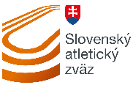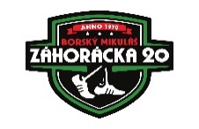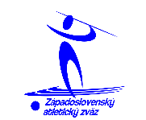

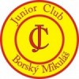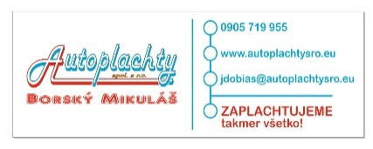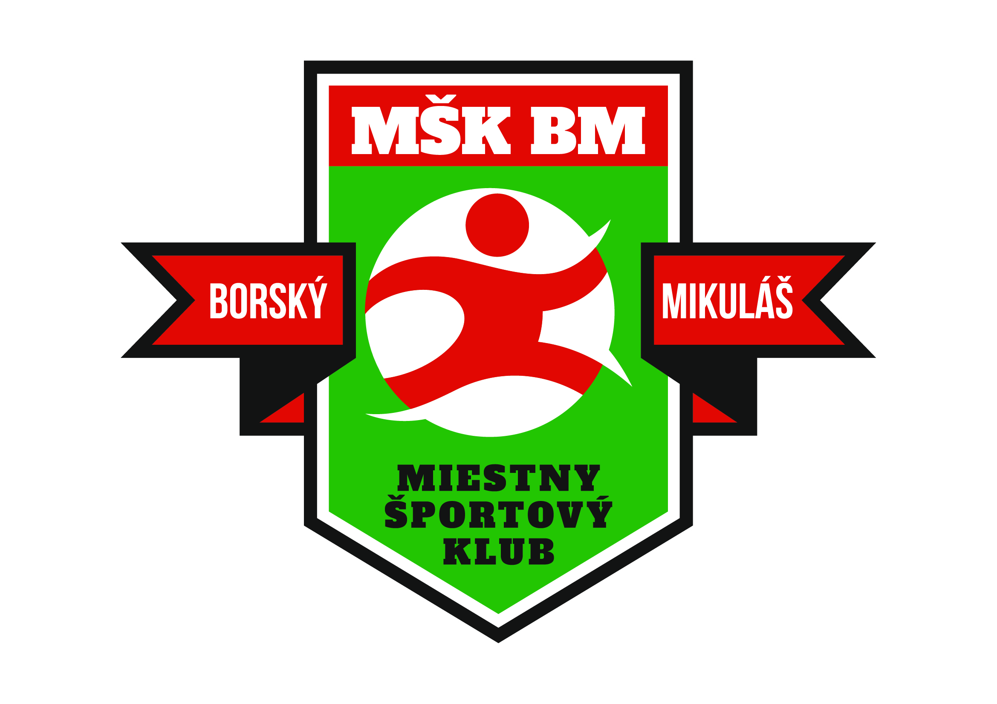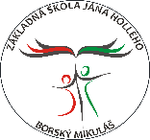

MEETING REKORD.

U10 1km
5:05 Filip KRESTIANKO Dukla Banská Bystrica SVK 2014
5:05 Michal BENČÍK ŠK BCF Dukla Banská Bystrica SVK 2021
5:05 Dominika PERNICKÁ ŠK BCF Dukla Banská Bystrica SVK 2019

U12 1km
4:42 Dominika PERNICKÁ ŠK BCF Dukla Banská Bystrica SVK 2021
4:35 Vladimir SAVANOVIČ Nevena Leskovac YUG 1996

U14 2km
9:25 Lena LAUNIKONYTE Birštonas LTU 1994
9:22 Miroslav MRÁZ UMB Banská Bystrica SVK 1994

U16 3km
13:41 Edina FŰSTI DIAC Ózd HUN 1997
13:19 Detlef BRETAG Dynamo Eisenhűttenstadt GER 1981

U18 5km
24:18 Emilia GREZIAK POL 2015
21:30 Radovan ELKO OŠG Košice SVK 1997
21:30 Miroslav MRÁZ UMB Banská Bystrica SVK 1998

U18 10km
44:40 Jiří CHALOUPKA CZE 2002
50:47 Zuzana MALÍKOVÁ TJ Lokomotíva Šurany SVK 2000

U20 5km
23:27 Eszter GERENDASI HUN 2004

U20 10km
47:05 Zuzana MALÍKOVÁ TJ Lokomotíva Šurany SVK 2001
41:23 Jose ORTIZ FLOREZ GUA 2019

Womens 5km
22:16 Viktoria MADARASZ HUN 2014

Womens 10km
42:57 Ljudmyla OLYANOVSKA Ukrajina UKR 2022

Womens 20km
1:38:24 Tatiana RAGOZINA Ukrajina UKR 2000

Mens 10km
39:31 Ján ZÁHONČÍK Dukla Banská Bystrica SVK 1992
39:31 Callum WILKINSON GBR 2019

Mens 20km
1:21:42 Roman MRÁZEK Dukla Banská Bystrica SVK 1987

Masters 5km
26:51 Carmen GARCIA ESP 2003
21:17 Bohdan BULAKOWSKI Skra Warszawa POL 1990

Masters Mens 10km
43:28 Milan RÍZEK AŠK Skalica - Team snov SVK 2014

Masters 20km
1:27:19 Alexander RAKOVIČ SRB 2004
1:38:43 Tatiana RAGOZINA UKR 2000

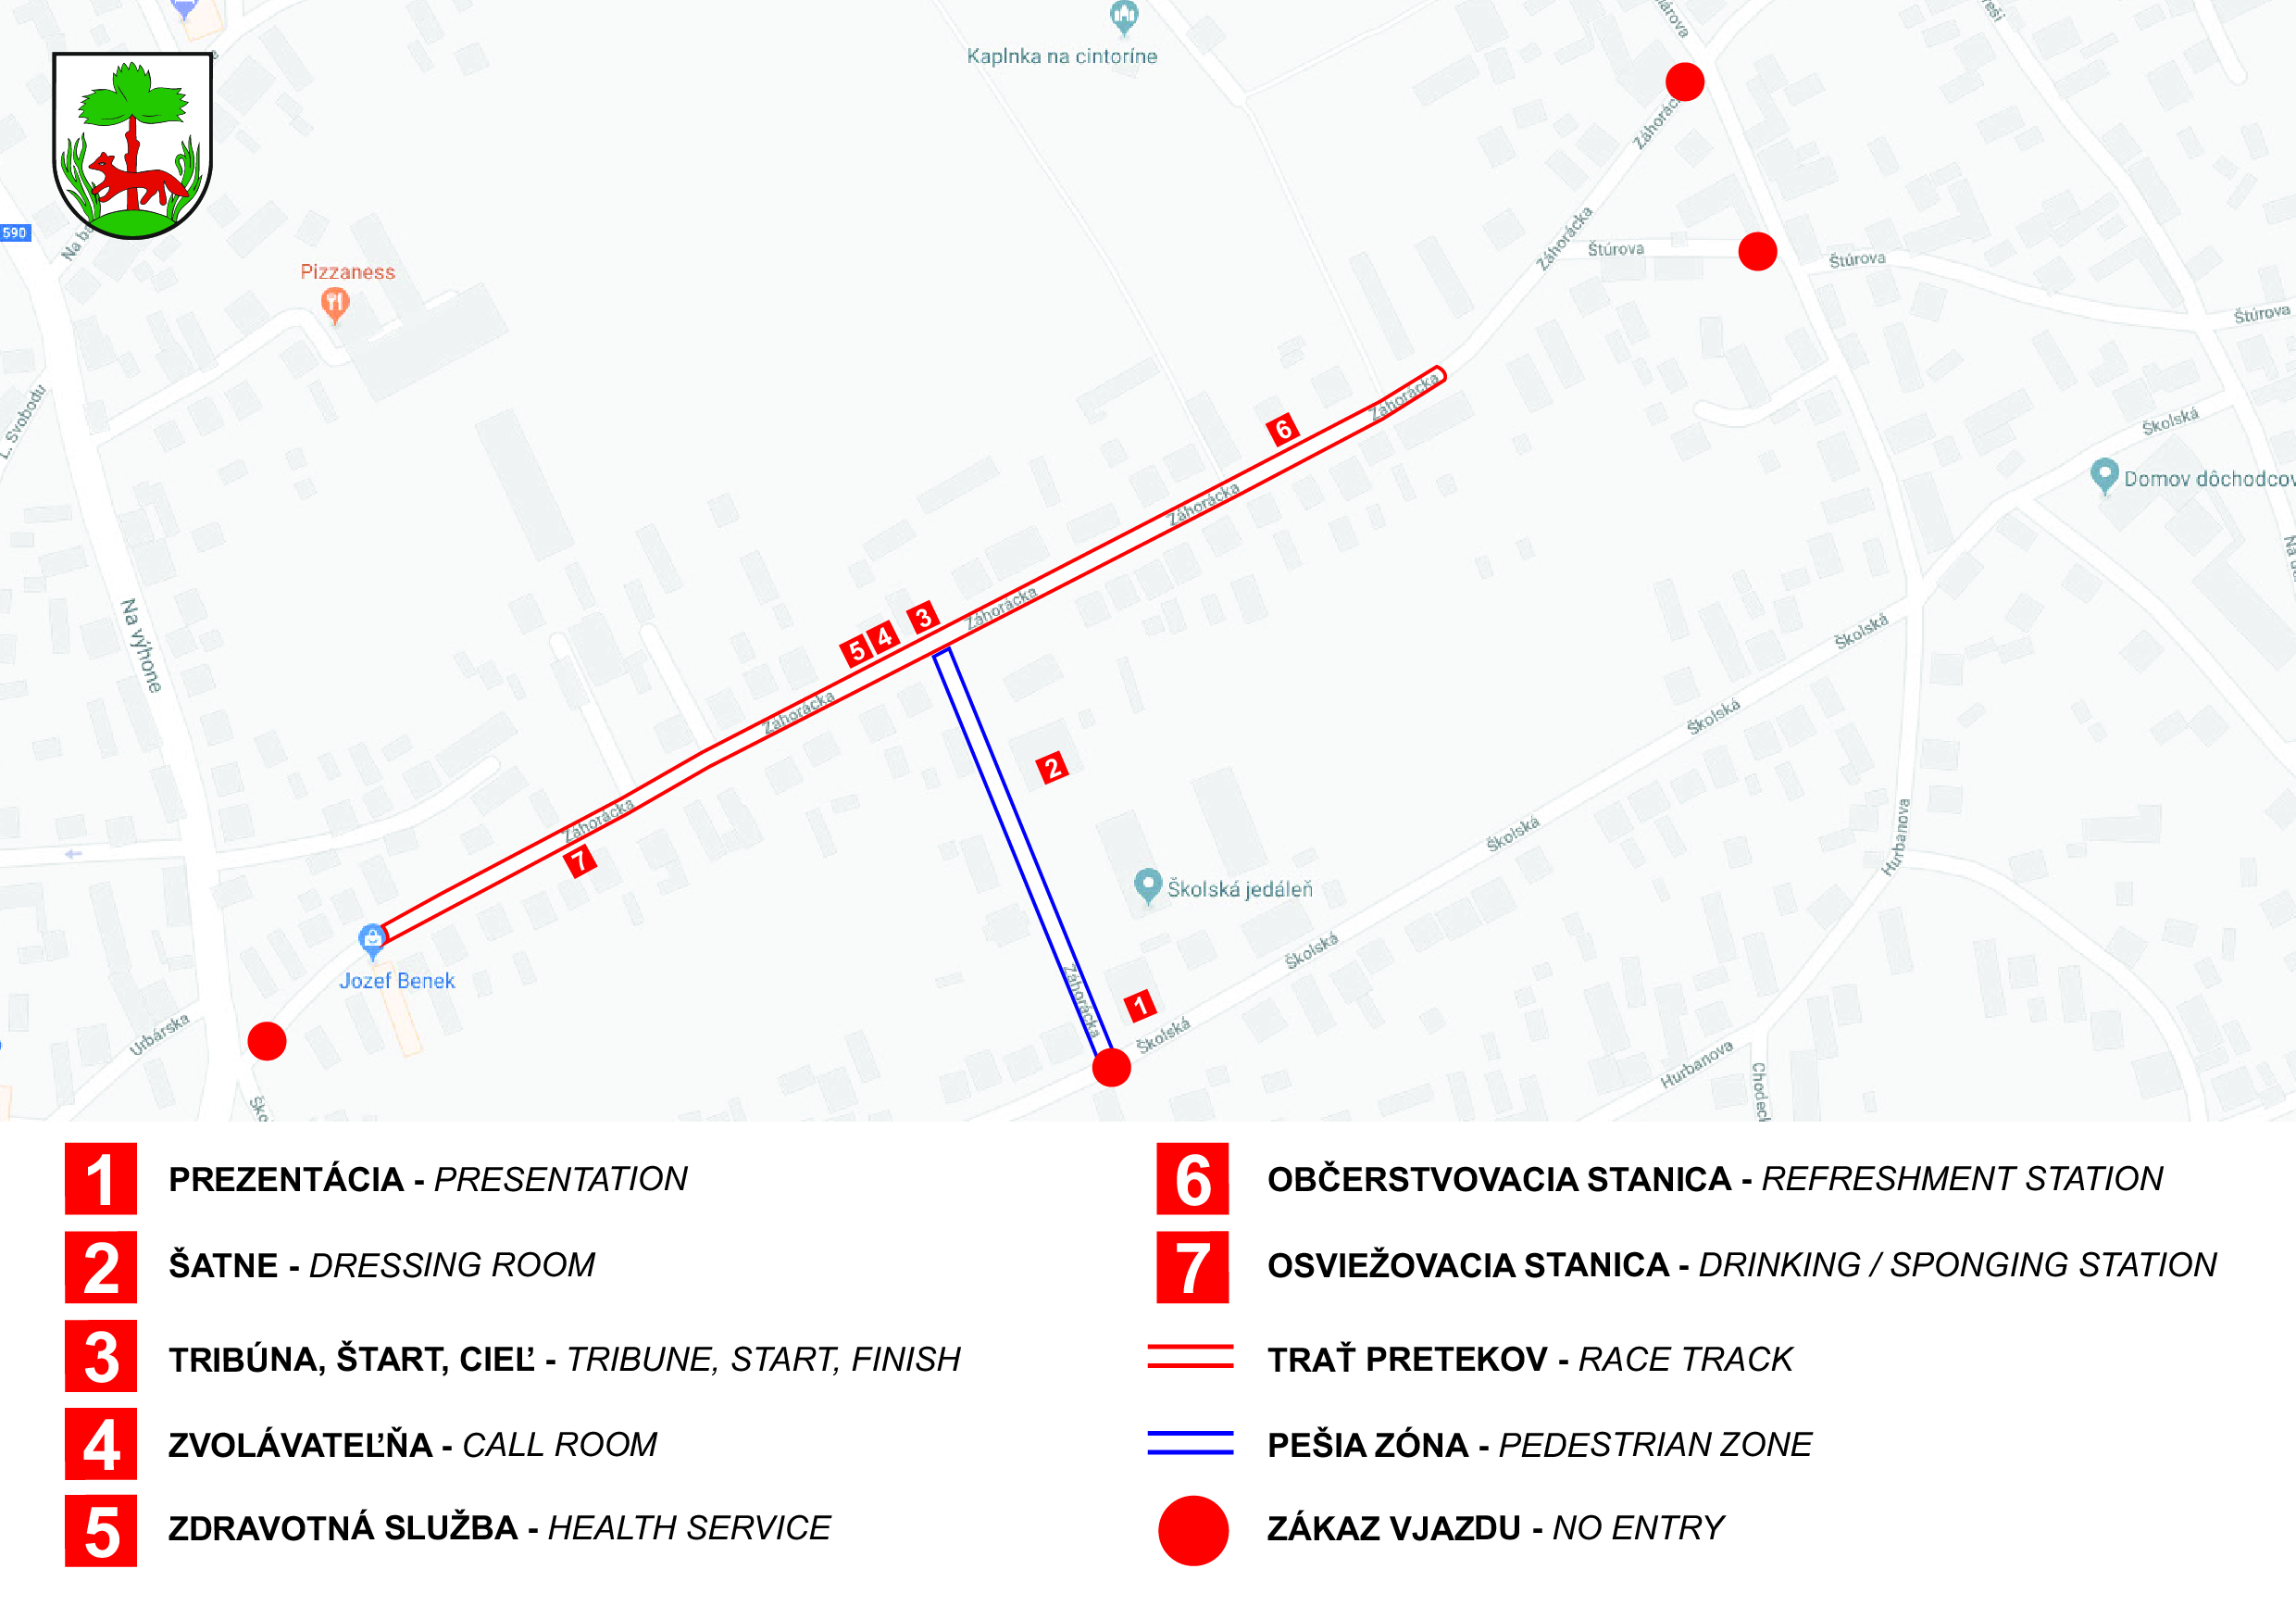

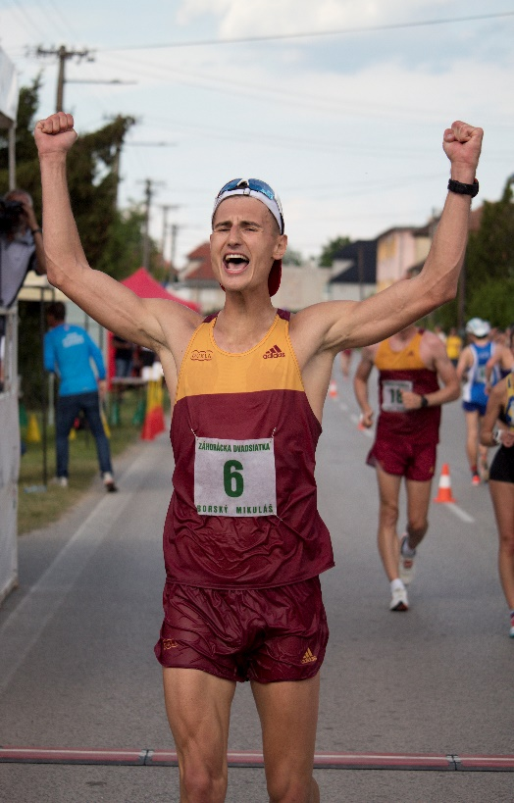

DOMINIK ČERNÝ
ŠK Dukla o.z. Banská Bystrica
53rd Záhorácka dvadsiatka
Winner of the men's 10km category

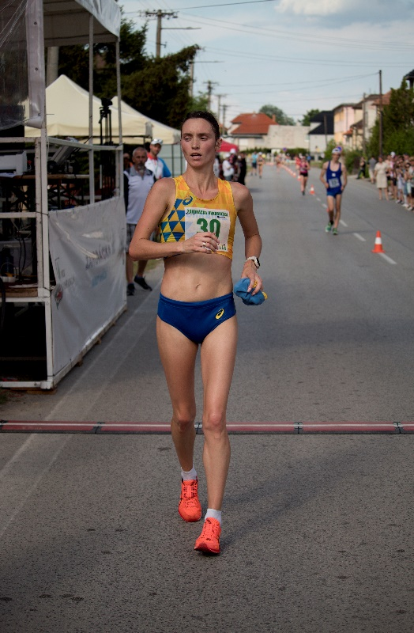

LJUDMYLA OLYANOVSKA
Ukraine
53rd Záhorácka dvadsiatka
Winner of the women's 10km category

